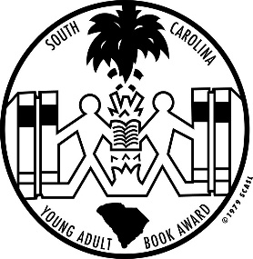
South Carolina
Young Adult Book Award Nominees
2020 - 2021

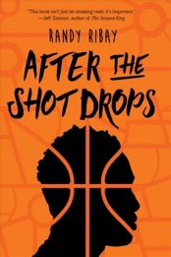
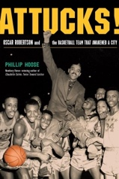
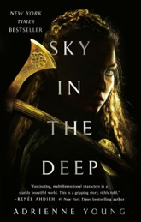
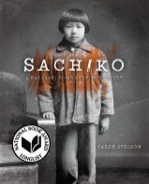
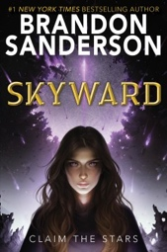
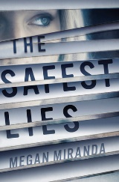
After the Shot Drops by Randy Ribay
Attucks!: Oscar Robertson and the Basketball Team
That Awakened a City by Phillip
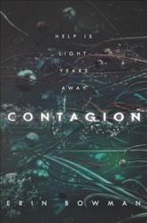
Contagion by Erin Bowman
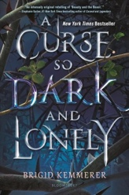
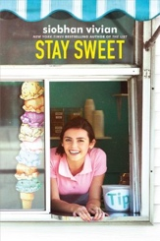
A Curse So Dark and Lonely by Brigid Kemmerer
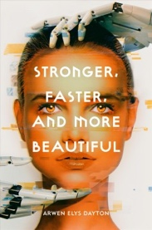
The Hazel Wood by Melissa Albert
Here to Stay by Sara Farizan
Heretics Anonymous by Katie Henry
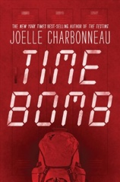
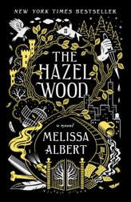
Hey Kiddo: How I Lost My Mother, Found My Father, and
Dealt with Family Addiction by Jarrett J. Krosoczka
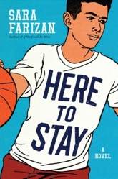
I Have the Right to: A High School Survivor’s Story
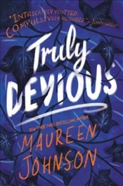
Sexual Assault, Justice, and Hope by Chessy Prout
The Silence Between Us by Alison Gervais
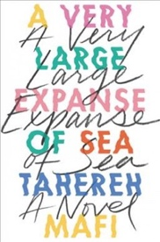
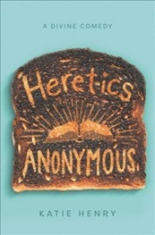
Sky in the Deep by Adrienne Young
Skyward by Brandon Sanderson
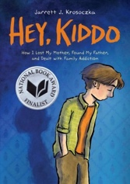
Stay Sweet by Siobhan Vivian
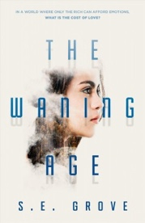
Stronger, Faster, and More Beautiful by Arwen Elys Dayton
Time Bomb by Joelle Charbonneau
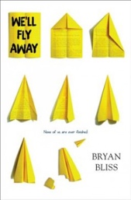
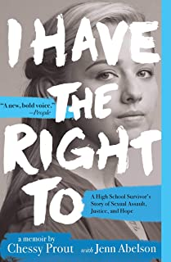
Truly, Devious by Maureen Johnson
A Very Large Expanse of Sea by Tahereh Mafi
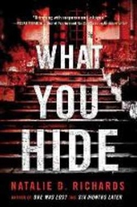
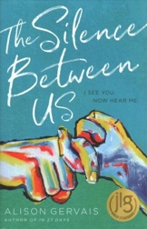
The Waning Age by S. E. Grove
We’ll Fly Away by Bryan Bliss
What You Hide by Natalie D. Richards
South Carolina Association of School Librarians
PO Box 2442, Columbia, SC 29202
All media specialists should review all titles and add them to their collection only if the titles meet the criteria established by District Board Policy and Library Media Center Policy & Procedure guidelines. We recommend that others interested in purchasing these titles read reviews and scan materials to determine the appropriateness for their intended readers.
Students: To be eligible to vote for your favorite book, you must read at least three of the nominee titles. Voting takes place in early February.
For more information about the SC Young Adult Book Awards program, see a library staff member.
Book images courtesy of Novelist Plus database: www.scdiscus.org.

